Word for Windows template for the contribution preparation

Mark Balkema

Institute for the hydraulic structures, Ljubljana, Slovenia

Louise Smith

Faculty of civil and geodetic engineering, University of Ljubljana, Slovenia

ABSTRACT: Authors of the papers for the proceedings have to type the abstract in a form suitable for direct reproduction by the publisher. In order to ensure uniform style throughout the volume, all the papers have to be prepared strictly according to the instructions set below. Please prepare you contribution in MS Word and a copy of the paper in PDF. The template file for MS Word 2016 is provided. Please make sure you use the MS Word 2016 or newer version for the preparation of the contribution. Use the “high quality print” settings in your Adobe Acrobat software for the PDF copy of the paper. Please use the Adobe Acrobat X of newer version for the preparation of the PDF copy.

**Type your abstract of not more than 300 words in English. The first line of the abstract will be 7.5 cm from the top. The complete abstracts (in English) will fall in the first page. Please use the pre-created Headings for the paper.**

# GENERAL INSTRUCTIONS

## Type area

The text should fit exactly into the type area (150 × 240 mm). The margin settings for A4 size paper are as shown in Table 1 (below). The letter size margins shown in Table 1 are not relevant to the Proceedings.

Table 1. Margin settings for A4 size paper and letter size paper.

_______________________________________________________________

Setting A4 size paper Letter size paper

________________ ________________

cm inches cm inches

_______________________________________________________________

Top 2.5 0.98" 1.75 0.69"

Bottom 3.0 1.18" 2.01 0.79"  
Left 3.0 1.18" 3.28 1.29"

Right 3.0 1.18" 3.28 1.29"

All other 0.0 0.0" 0.0 0.0"

_______________________________________________________________

## Typefont, typesize and spacing

Use Times New Roman 11 point size and 12 point line spacing (Standard text tag). Use roman type except for the headings (Heading tags), parameters in mathematics (not for log, sin, cos, ln, max., d (in d*x*), etc.), Latin names of species and genera in botany and zoology and the titles of journals and books which should all be in italics. Never use bold except to denote vectors in mathematics. Please do not underline any text. Use the small font (10 points on 11 points) for tables (Table tags), figure captions (Figure caption tag) and the references (Reference text tag). Never use letterspacing and never use more than one space after each other.

# Getting started

## Title, author and affiliation frame

Type the title of the paper in lower case (no caps except for proper names). The title should not be longer than 75 characters).

Type the name of the first author (first the given name and then the family name). If any of the co-authors have the same affiliation as the first author, add his name after an & (or a comma if more names follow). Type the correct affiliation; Name of the institute, City, State/Province, Country, *do not add street names, P.O. Box numbers or zip codes to the affiliations*. If there are authors linked to other institutes, place the cursor at the end of the affiliation line just typed and give a return. Now type the name(s) of the author(s) and after a return the affiliation. Repeat this procedure until all affiliations have been typed.

All the above texts should fit in the frame which should not be changed (Width: Exactly 15.0 cm; Height: Exactly 7.5 cm; Lock anchor).

## Abstract frame

If there are no further authors, place the cursor one space after the words ABSTRACT: and type your abstract of not more than 300 words in English. The first line of the abstract will be 7.5 cm from the top. The complete abstracts will fall in the first page, the settings of which should also not be changed (width: Exactly 15.0 cm or 5.91"; height: Automatic; vertical: 7.5 cm or from margin).

## First line of text or heading

If your text starts with a heading, replace GENERAL INSTRUCTIONS with the correct text for the heading. Start with the text after a return. This text should have the tag First paragraph.

If your text starts without a heading, you should place the cursor immediately before GENERAL INSTRUCTIONS, change the tag to First paragraph and type your text after deleting the words GENERAL INSTRUCTIONS, but not the return at the end.

# Layout of text

## Text and indenting

All text, figures, tables, etc. should fit exactly in the type area of 15 × 24 cm (5.91" × 9.52"). All text should be typed in Times New Roman. All text is 11 pt on 12 pt line spacing except for the paper title (16 pt on 18 pt), author(s) (12 pt on 13 pt), affiliation(s) (10 pt on 11 pt) and the small text in tables, captions and references (10 pt on 11 pt). All line spacing is exact. Never add a line space between lines or paragraphs.

First lines of paragraphs are indented 4 mm (0.16") except for paragraphs after a heading or a blank line (First paragraph tag). Equations are indented 12 mm (0.47") (Formula tag).

## Headings

Type primary headings in capital letters roman (Heading 1 tag) and secondary and tertiary headings in lower case italics (Headings 2 and 3 tags). Headings are set flush against the left margin. The tag will give two blank lines (24 pt) above and one (12 pt) beneath the primary headings, 1½ blank lines (18 pt) above and a ½ blank line (6 pt) beneath the secondary headings and one blank line (12 pt) above the tertiary headings. Headings are not indented and neither are the first lines of text following the heading indented. If a primary heading is directly followed by a secondary heading, only a ½ blank line should be set between the two headings.

In Word, this has to be done manually as follows: place the cursor on the primary heading, select Paragraph in the Format menu, and change the setting for spacing after, from 12 pt to 0 pt. In the same way the setting in the secondary heading for spacing before should be changed from 18 pt to 6 pt.

## Listing and numbering

For listing facts, use either the style tag List summary signs or the style tag List number signs.

## Equations

Use the equation editor of the Word program. Equations are indented 12 mm (0.47") from the left margin (Formula tag). Number equations consecutively and place the number with the Tab key at the end of the line, between parentheses. Refer to equations by these numbers. See for example Equation 1 below:

From the above, we note that sin θ = (*x* + *y*)*z* or

 (1)

where *ca* = interface adhesion; δ = friction angle at interface; and *k*1 = shear stiffness number.

## Tables

Locate tables close to the first reference to them in the text and number them consecutively. Avoid abbreviations in column headings. Indicate units in the line immediately below the heading. Explanations should be given at the foot of the table, not within the table itself. Use only horizontal rules: one above and one below the column headings and one at the foot of the table. For simple tables, use the Tab key and not the table option. Type all text in tables in small type (Table text tag). Align all headings to the left of their column and start these headings with an initial capital. Type the caption above the table to the same width as the table (Table caption tag). See for example Table 2.

## Figure captions

Always use the Figure caption style tag (10 points size on 11 points line space). Place the caption underneath the figure (see example in Section 4). Type as follows: ‘Figure 1. Caption.’ Leave about two lines of space between the figure caption and the text of the paper.

Table 2. The number of officially reported plague cases in the world.

_____________________________________________________________________________

Region* 1968 1970 1972 1974 1976 1978

_____________________________________________________________________________

Africa 172 27 85 128 183 77

America 392 326 301 297 321 142

Asia 4395 4111 2312 1408 2230 518

Total 4959 4464 2698 1833 2734 737

_____________________________________________________________________________

*For Europe only one reported case in 1970.

## References

In the text, place the authors’ last names (without initials) and the date of publication in parentheses (see examples in Section 3.7.1). At the end of the paper, list all references in alphabetical order underneath the heading REFERENCES (Heading without number tag). The references should be typed in small text (10 pt on 11 pt) and second and further lines should be indented 4.0 mm (Reference text tag). If several works by the same author are cited, entries should be chronological:

Smith, A.B. 2016a. Numerical analysis of...

Smith, A.B. 2016b. Computation of...

Smith, A.B. 2017. Computer ...

Smith, A.B. & Jensen, M.C. 2006. Effects of ...

Smith, A.B. & Author, B.P. 2013. Impacts ...

In bibliographies the order for books and journals are respectively:

Last name, First name or Initials (ed.) year. *Book title*. City: Publisher.

Last name, First name or Initials. year. Title of article. *Title of Journal* (series number if necessary) volume number (issue number if necessary): page numbers.

### Examples:

Grove, A.T. 1980. Geomorphic evolution of the Sahara and the Nile. In M.A.J. Williams & H. Faure (eds), *The Sahara and the Nile*: 21-35. Rotterdam: Balkema.

Jappelli, R. & Marconi, N. 1997. Recommendations and prejudices in the realm of foundation engineering in Italy: A historical review. In Carlo Viggiani (ed.), *Geotechnical engineering for the preservation of monuments and historical sites*; *Proc. intern. symp., Napoli, 3-4 October 1996*. Rotterdam: Balkema.

Johnson, H.L. 1965. Artistic development in autistic children. *Child Development* 65(1): 13-16.

Polhill, R.M. 1982. *Crotalaria in Africa and Madagascar*. Rotterdam: Balkema.

## Notes

The notes should be avoided. Insert the information in the text. In tables by using the reference marks. The following marks should be used: *, **, etc. and the actual footnotes are then set directly underneath the table.

## Conclusions

Conclusions should state concisely the most important propositions of the paper as well as the author’s views of the practical implications of the results.

# Photographs and figures

Number figures consecutively in the order in which reference is made to them in the text, making no distinction between diagrams and photographs. Figures should fit within the type area width of 187 mm (7.36").

Paste copies of figures, photographs etc. at the required size onto the typescript where you want them to appear in the text. Do not place them sideways on a page. Figures, etc. should not be centered, but placed against the left margin. Leave about two lines of space between the actual text and figure (including caption). Never place any text next to a figure. Leave this space blank. The most convenient place for placing figures is at the top or bottom of the page. Avoid placing text between figures as readers might not notice the text. Line drawings (as well as photographic reproductions of these) should be in black (not grey) on white. Keep in mind that everything will be reduced to 75%. Therefore, 9 point should be the minimum size of the lettering. Lines should preferably be 0.2 mm (0.1") thick. Keep figures as simple as possible. Avoid excessive notes and designations.

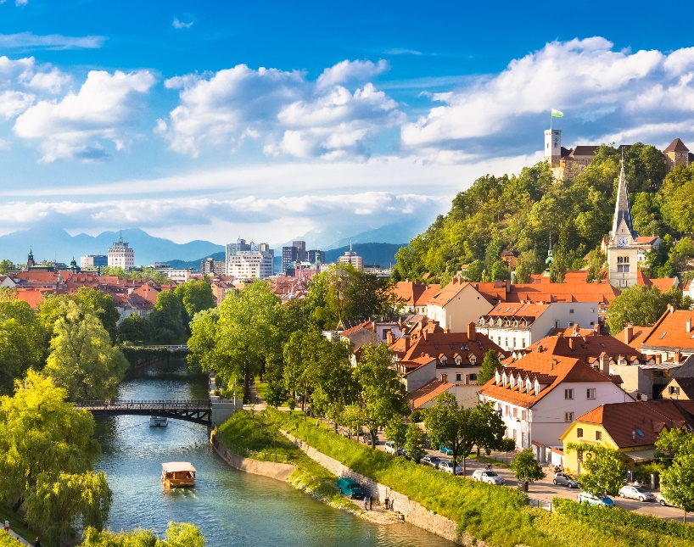

Figure 1. Caption of a typical figure.

# PREFERENCES, SYMBOLS AND UNITS

Consistency of style is very important. Note the spacing, punctuation and caps in all the examples below.

1. References in the text: Figure 1, Figures 2-4, 6, 8a, b (not abbreviated)
2. References between parentheses: (Fig. 1), (Figs 2-4, 6, 8a, b) (abbreviated)
3. USA / UK / The Netherlands instead of U.S.A. / U.K. / Netherlands / the Netherlands
4. Author & Author (1989) instead of Author and Author (1989)
5. (Author 1989a, b, Author & Author 1987) instead of (Author, 1989a,b; Author and Author, 1987)
6. (Author et al. 1989) instead of (Author, Author & Author 1989)
7. Use the following style: (Author, in press); (Author, in prep.); (Author, unpubl.); (Author, pers. comm.)

Always use the official SI notations:

1. kg / m / kJ / cm *instead* *of* kg. (Kg) / m. / kJ. (KJ) / cm.;
2. 20°16′32′′SW *instead of* 20° 16′ 32′′ SW
3. 0.50 *instead of* 0,50 (*used in French text*); 9000 *instead of* 9,000 *but if more than* 10,000: 10,000 *instead of* 10000
4. 14C *instead of* C14 / C-14 *and* BP / BC / AD *instead of* B.P. / B.C. / A.D.
5. 20 *instead of* ×20 / X20 / x 20; 4 + 5 > 7 *instead of* 4+5>7 *but* –8 / +8 *instead of* – 8 / + 8
6. e.g. / i.e. *instead of* e.g., / i.e.

# Submission of material to the editor

The copy PDF file of the complete paper should be created and sent to the editor together with the Word file. All figures should be included as high resolution images in the PDF file (see artwork document for resolution requirements). Check whether the paper looks the same as this sample: Title at top of first page in 18 points, authors in 14 points and all other text in 11 points on 12 points line space, except for the small text (10 point on 11 point line space) used in tables, captions and references. Also check if the type width is 187 mm (7.36"), the page length is 272 mm (10.71") and that the space above the ABSTRACT is exactly as in this sample.

# NAME OF THE FILE

The file should be named as follows BW 2022_Theme_A(B, C, O)_ Family name of the author_ Title of the paper.